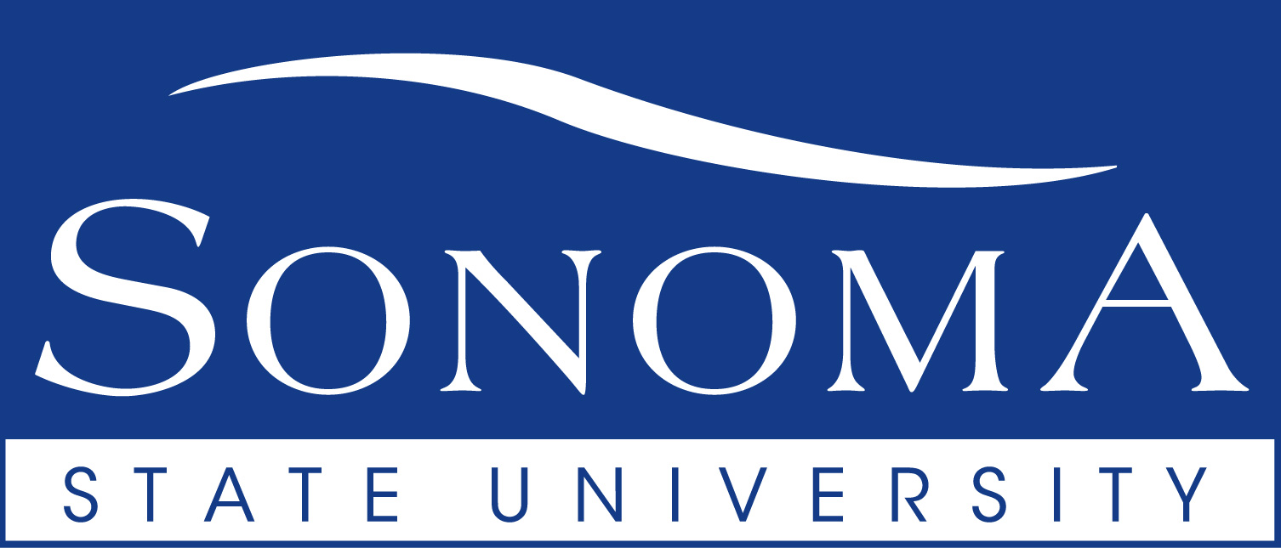

Student Affairs Briefing on SSU Branding Initiative   
*Tuesday, Sept. 24, 2019 – By Paul Gullixson, AVP Strategic Communications*

PROJECT OVERVIEW

In partnership with the creative agency The Engine is Red, Sonoma State has launched a branding and marketing initiative that seeks to capitalize on the Strategic Planning process in developing a dynamic brand and messaging that captures the university’s key values, priorities and attributes. The goal is to foster deeper connections with prospective students, current students, alumni, donors, prospective employees, community members and other audiences.

DELIVERABLES

The Engine is Red will work to create:

* A full set of brand elements, including logo guidelines, color palette, fonts, etc. and clear, advanced messaging for SSU.
* A Brand Guidelines book that will explain how our brand and brand elements work. To be used for all marketing campaigns, communications and products/services.
* All brand assets will be delivered to the SSU team electronically, which will then be shared with faculty, staff and students.

TIMELINE

The project has been broken down into a series of goal-based phases:

**Phase 1 | Discovery – September** *(approx.)*

During this phase, the Engine and SSU team will be leveraging from the Strategic Plan process while gathering data and insights from surveys of faculty, staff, students, donors and community members and by conducting interviews and hosting focus groups. This phase includes identifying key decision-makers and stakeholders, sharing and talking through findings from the Strategic Plan, determining brand elements to be updated, gathering existing marketing materials and meeting with those who will be utilizing the Brand Book.

**Phase 2 | Concepting - October**

During this second phase, the Engine will be leveraging from the strategic and discovery work from phase one to create multiple creative concepts including messaging and visuals.

*Deliverables:*

* Creation of multiple creative concepts to be shared with the SSU team
* Goal is to develop consensus from decision-making team on a single concept direction

**Phase 3 | Refinement – November**

In the third phase, the Engine team will begin to build out the remaining brand elements based off of the consensus from phase two, while also refining the brand elements set as a single unit. After incorporating client feedback, the Engine will leverage from the approval process in phase one to establish a consensus and final approval.

*Deliverables:*

* Final approval from lead decision-makers (Cabinet and Branding Work Group)
* Full set of brand elements and evolved set of messaging developed

**Phase 4 | Finalization + Rollout Strategy – December to January 2020**

In this final phase, the Engine team will be exporting the brand assets and outlining the Brand Book while producing the pages needed for it. The Engine team will be sharing weekly progress with the SSU team and incorporating feedback as needed. Rollout will include meeting with departments, schools and various units involved in communications to train in use of branding elements.

*Deliverables:*

* Brand guidelines book created and posted on SSU website.